Atividade roteamento

Lucas Orestes Fabris

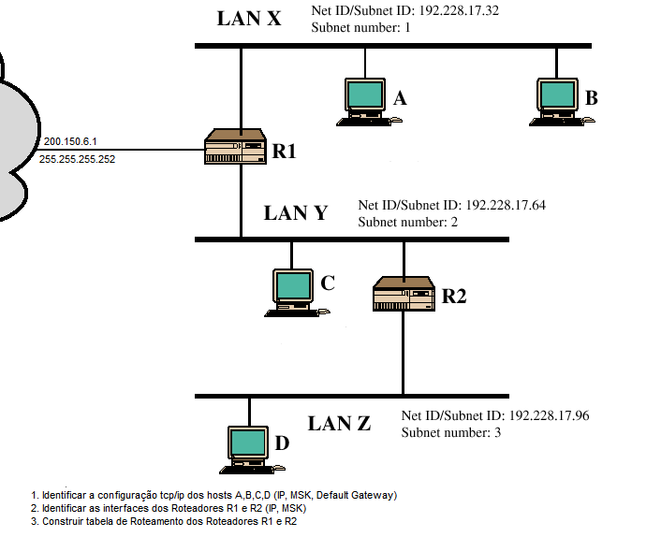

A = IP:192.228.17.34 - 255.255.255/27

gw:192.228.17.33

B = IP:192.228.17.35 - 255.255.255/27

gw:192.228.17.33

C = IP:192.228.17.66 – 255.255.255/27

gw:192.228.17.65

D = IP:192.228.17.98 – 255.255.255/27

gw:192.228.17.97

R1

i1:192.228.17.33

i2:192.228.17.65

R2

i1:192.228.17.67

i2:182.228.17.97

R1

|  |  |  |
| --- | --- | --- |
| REDE | MASCARA | PROXIMO |
| 192.228.17.32 | 255.255.255.0 | Direto |
| 192.228.17.64 | 255.255.255.0 | Direto |
| 0.0.0.0 | 0.0.0.0 | 200.150.6.1 |

R2

|  |  |  |
| --- | --- | --- |
| REDE | MASCARA | PROXIMO |
| 192.228.17.64 | 255.255.255.0 | Direto |
| 192.228.17.96 | 255.255.255.0 | Direto |
| 0.0.0.0 | 0.0.0.0 | 192.288.17.65 |